**Mental Health in Tech**: People working in tech are often at their desks for extended amounts of time. In this project, we explored how this trend correlates with mental health within the tech industry.

**Group Members**

1. Keegan
2. Lishi
3. Loku
4. Jane

## **The main questions we used to guide our analysis were:**

1. How do employees perceive their workplace culture regarding mental health?
2. Do males seek mental health treatments less often than females in tech companies?
3. Is mental health more prevalent in different regions? Does US have a bigger issue with mental health compared to other countries?
4. Does mental health interfere with work?

## **Analysis: How do employees perceive their workplace culture regarding mental health?**

There is a survey done in 2016 and the question is about people’s willingness to discuss physical health issue compared to mental health issue, from the bar chart we could see 44% of people are somewhat willing to discuss physical health issues ("Maybe Yes"). 25% are willing to discuss physical health openly ("Yes"). However 62% of people are unwilling to discuss mental health issues ("No"). Only 8% are willing to discuss mental health openly ("Yes"). So we could see that although organizations are focusing on raising awareness through initiatives like Are You Okay Day, people are still far more comfortable discussing physical health than mental health.

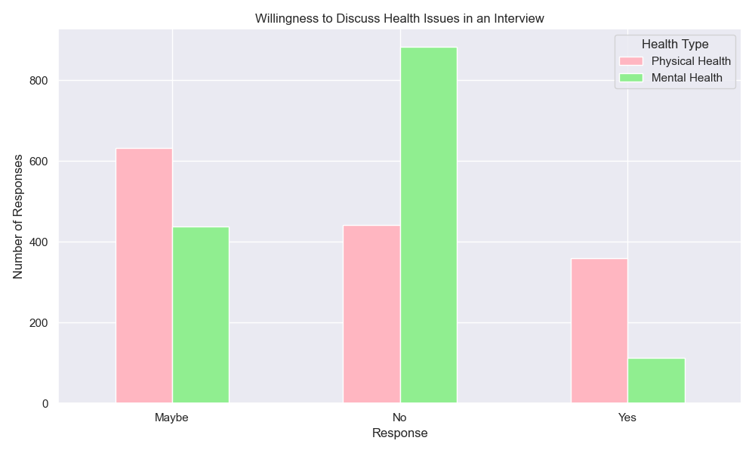

A survey question about the impact of being identified with a mental health issue on one's career is designed to uncover the reasons why people may be reluctant to discuss mental health. 51% of respondents firmly believe mental health issues could impact careers and 32% believe the health issue may impact careers. However, Only 10 % (9% + 1.5%) report actual negative career impacts.

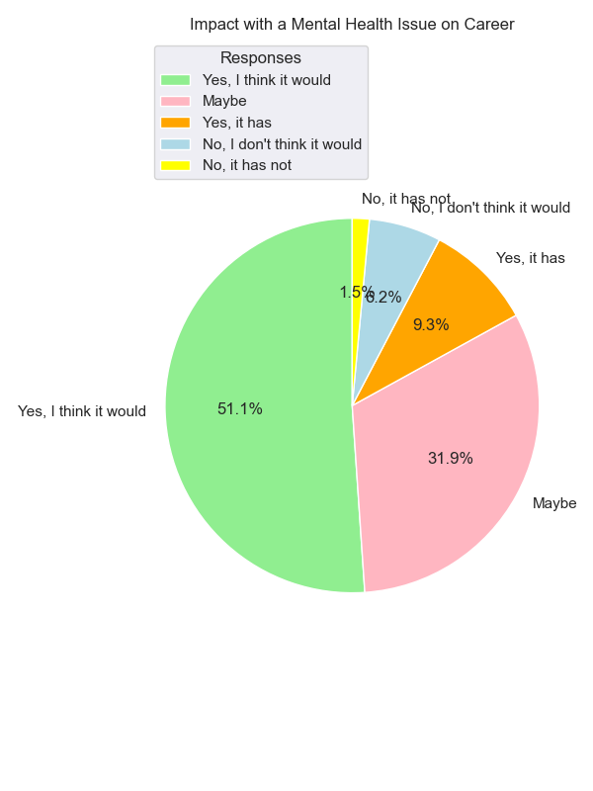

So a significant majority of people perceive mental health issues as a potential threat to career progression, which may lead to hesitation in disclosing mental health concerns. However, there is a clear discrepancy between perception and reality. While many people have concern about career progression, the actual number of those affected is much lower.

Understanding the stigma surrounding mental health is crucial, as it remains a significant barrier to open discussions and support. Many individuals still hold the belief that mental health challenges can negatively impact their careers, which reflects the ongoing stigma that persists in professional environments.

By fostering supportive environments in the workplace, organizations can help employees feel more comfortable seeking help, ultimately promoting a healthier, more inclusive, and productive work culture.

## **Analysis: Do males seek mental health treatments less often than females in tech companies?**

1. Overall Mental Health Treatment Seeking by Gender Code Purpose: This bar graph shows the overall count of males and females who have sought mental health treatment, regardless of their country. The data is grouped by gender to identify how frequently males and females seek help from mental health professionals in the tech industry. Key Insights: From the bar graph, I observe that males are more likely to seek treatment for mental health issues compared to females. This supports a common trend observed across industries: males tend to be more proactive in seeking mental health support, while females are more likely to avoid or delay treatment.
2. Pie Chart: Proportion of Mental Health Treatment Seeking by Gender

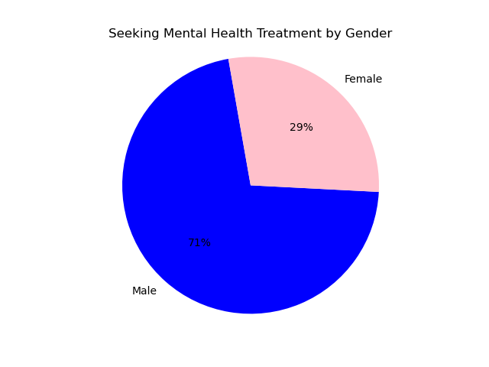

Code Purpose: The pie chart gives a proportionate view of percentage males and females have sought mental health treatment overall. Each slice of the pie represents the percentage of male and female tech employees who answered 'Yes' to seeking mental health treatment.

Key Insights: The pie chart visually confirms the findings from the bar graph: a larger portion of males seek treatment for mental health issues compared to females. I see that 71% of the individuals who sought mental health treatment are male, while 29% are female. The percentage values make it clear that males make up a significantly higher proportion of mental health treatment seekers in the tech industry.

3. Last Bar Graph: Mental Health Treatment Seeking by Gender (US vs. Non-US)

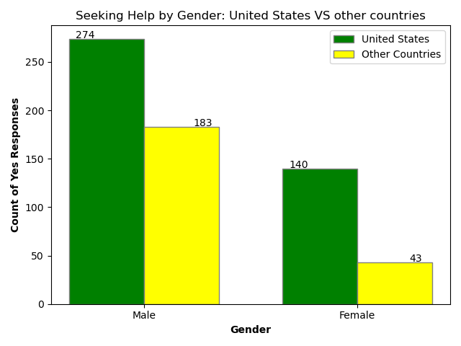

Code Purpose: This graph compares the mental health treatment-seeking behavior between tech workers in the United States and other countries, with the data broken down by gender. The grouped bars (one set for the US and one for non-US countries) show how males and females behave in terms of seeking mental health treatment in different regions.

Key Insights: In the United States: Males are more likely to seek mental health treatment than Females, reflecting the same trend seen in the overall data. This suggests that even in a tech-heavy environment like the US, females may be less comfortable seeking mental health care. Outside the United States: The same gender-based difference is seen, with males seeking treatment more than females, although the gap may vary depending on specific regions or cultures.

Conclusion: Across all the graphs, I consistently see that males are more likely to seek mental health treatment than females in the tech industry, both in the United States and globally. These insights highlight the need for gender-sensitive approaches to mental health support in the tech industry, especially encouraging females to seek the care they need.

## **Analysis: Is mental health more prevalent in different regions? Does US have a bigger issue with mental health compared to other countries?**

Our data indicates that individuals in the USA are significantly more likely to seek mental health treatment, with the number of responses seeking help being doubled compared to countries outside the USA.

In contrast, there is a slight increase in the number of individuals outside the USA who report not seeking treatment.

This disparity may suggest that mental health is prioritized more highly in the USA compared to other countries, highlighting potential cultural differences in the perception and importance of mental health care USA - YES: 550 - NO: 289

Outside USA - Yes: 290 - NO: 304

US: Yes = 65.48%, No = 34.52%

Other Countries: Yes = 48.74%, No = 51.26%

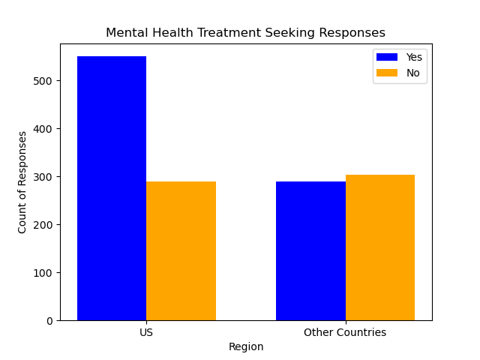

Our data indicates that individuals in the USA are significantly more likely to seek mental health treatment, with 65.48% of responses indicating they have sought help compared to only 48.74% of individuals outside the USA. Specifically, in the USA, 550 individuals reported seeking treatment (Yes), while 289 did not (No). In contrast, 290 individuals outside the USA sought treatment, while 304 reported not seeking help.

This Visible difference suggests that mental health is prioritized more highly in the USA compared to other countries, highlighting cultural differences in the perception and importance of mental health care.

The higher percentage of treatment-seeking behavior in the USA may be influenced by factors such as greater public awareness, access to mental health resources, and reduced stigma surrounding mental health issues.

Also, the slight increase in the number of individuals outside the USA who report not seeking treatment (51.26%) compared to those who do (48.74%) raises questions about the barriers to mental health care in those regions. This trend indicates a need for improved mental health awareness and resources in countries outside the USA.

Workplaces that offer help for Mental Health (USA vs Outside)

Data percentages USA yes: 33%, NO: 40%, IDK: 27%

Outside USA: YES: 18%, no: 63%, IDK: 19%

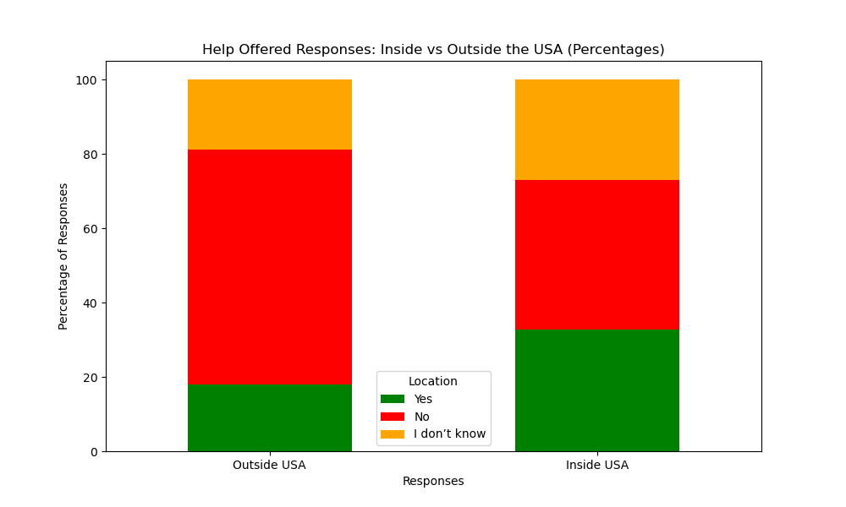

Our data indicates that 33% of respondents in the USA reported that their workplace offers mental health support, compared to only 18% of respondents from countries outside the USA.

In the USA, 40% responded "No" and 27% answered, "I don't know." Compared to outside the USA, 63% responded "No" and 19% said "I don't know."

These findings suggest that while both regions have significant portions of individuals who are uncertain or do not receive mental health support, the USA demonstrates a greater emphasis on mental health initiatives in the workplace.

This reinforces the notion that mental health may be prioritized more highly in the USA compared to other countries.

In our findings of workplace mental health support, we found notable differences between responses in the USA and those from other countries.

In the USA, 33% reported that their workplace offers mental health support, while only 18% of respondents from outside the USA indicated the same.

However, it's important to note that 40% of respondents in the USA answered "No" to the question of whether their workplace provides mental health support, and 27% responded "I don't know." In contrast, among respondents from other regions, 63% answered "No," and 19% said "I don't know."

These findings suggest that while a significant portion of individuals in both regions are uncertain about or do not receive mental health support, the USA appears to place a greater emphasis on mental health initiatives in the workplace. This further reinforces a higher prioritization of mental health in the USA compared to other countries.

However, the data also highlights a concerning trend: despite having more workplace treatment options for mental health, the USA faces a larger issue with mental health challenges among its workforce.

## **Analysis: Does mental health interfere with work?**

Most people in tech seem to have mental disorders, with about 40.1% responding 'yes' regarding mental health disorders, while 22.8% responded 'maybe,' and only 37.1% said 'no.'

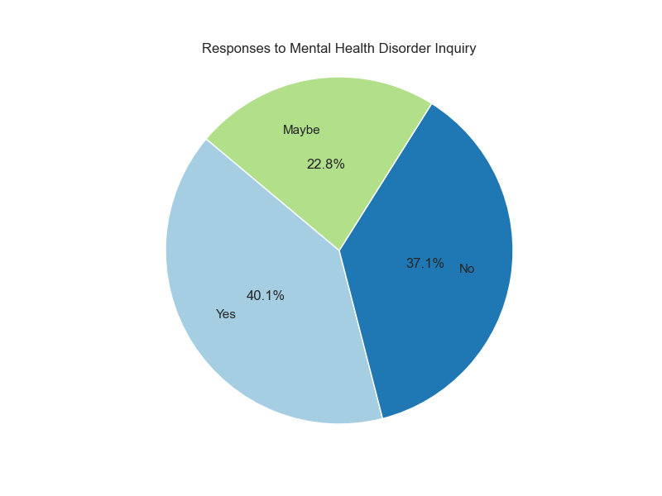

40.1% of respondents reported 'yes' which indicates that mental health is a critical issue that may need to be addressed in this industry. The 22.8% who responded 'maybe' reflects a level of uncertainty or lack of awareness regarding mental health disorders. This could point to the need for more education and resources about mental health in the workplace.

The 37.1% who said 'no' indicates that individuals do not identify with having a mental health disorder. However, this figure is still lower than the percentage of those who believe they do, which may suggest that mental health issues are more common than perceived.

Given the high percentage of individuals acknowledging mental health disorders, it may be beneficial for tech companies to implement mental health initiatives, such as wellness programs, mental health days, and access to counseling services. This could help create a more supportive environment for employees.

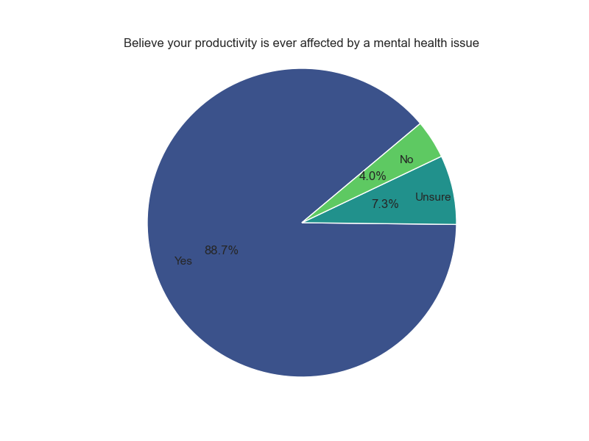

A significant majority (88.7%) of individuals with a mental disorder believe that their productivity is affected.

Meanwhile, 7.3% are uncertain, and only 4.0% reported that it does not impact their productivity.

The fact that 88.7% of individuals believe their productivity is affected by their mental disorder indicates a strong awareness of the relationship between mental health and work performance. This suggests that mental health issues are a significant concern for a large portion of the workforce.

With only 4.0% reporting that their productivity is not impacted, it highlights that very few individuals feel unaffected by their mental health challenges. This could imply that mental health disorders are commonly perceived as disruptive to work.

The 7.3% of respondents who are uncertain about the impact on their productivity may reflect a lack of awareness or understanding of how their mental health affects their work. This uncertainty could be an opportunity for organizations to provide education and resources to help individuals better understand their situations.

With the overwhelming majority indicating that their productivity is affected suggests a strong need for workplaces to address mental health issues proactively. This could include implementing mental health programs, providing access to counseling services, and creating a supportive work environment.

When it comes to the extent to which mental health disorders interfere with work, the responses were as follows: 39.1% indicated minimal influence (1-25%), 31.8% reported moderate influence, 18.2% noted moderate to severe influence, and approximately 10% believed that mental health disorders could have a substantial impact on their work (76-100%).

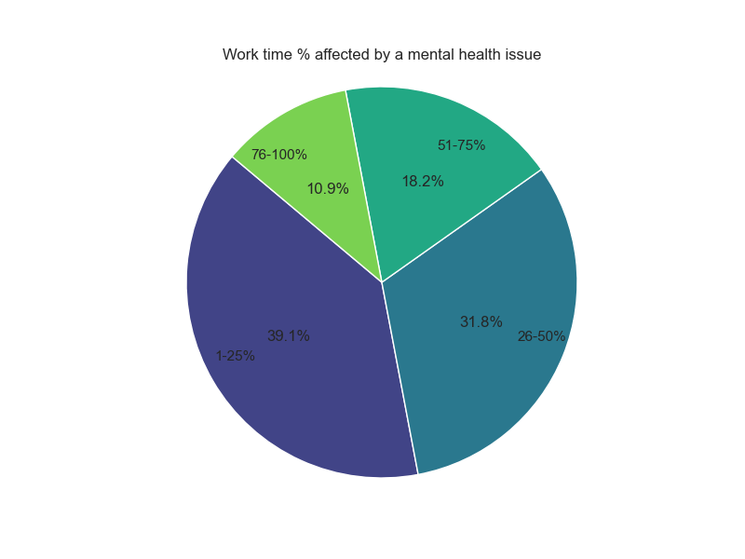

The fact that 39.1% of respondents reported minimal influence (1-25%) suggests that a significant portion of individuals may be managing their mental health challenges effectively.

With 31.8% reporting moderate influence, it indicates that a substantial number of individuals experience some level of disruption in their work due to mental health issues. This could point to the need for workplace support systems.

For the 18.2% who noted moderate to severe influence, along with the 10% who believe in a severe impact (76-100%), highlights a critical area of concern. This indicates that almost 1/3 of the workforce is significantly affected, which could lead to decreased productivity, increased absenteeism, and higher turnover rates.

This raises the need for awareness and resources related to mental health in the workplace. Organizations might consider implementing mental health programs, providing training for managers, and fostering a supportive environment to help those who are affected.

## **Conclusions**

The analyses of mental health in the workplace, particularly within the tech industry, reveal a complex landscape characterized by significant disparities, prevalent stigma, and the urgent need for comprehensive support systems.

Firstly, there is a notable reluctance to discuss mental health issues, This highlights a persistent stigma that organizations must address to foster a culture of openness and support.

Secondly, gender disparities in seeking mental health treatment are evident, as males are more likely to pursue help than females. This suggests the need for gender-sensitive strategies within organizations to encourage all employees to access mental health resources.

Additionally, despite higher availability of workplace mental health support, the USA still faces significant mental health challenges, indicating that access alone is insufficient without addressing underlying issues and stigma.

Finally, high amounts of employees believe their productivity is affected. This underscores the critical need for tech companies to implement comprehensive mental health initiatives, such as wellness programs and counseling services, to create supportive environments that enhance employee well-being and productivity.

To summarize, addressing mental health in the workplace requires a multifaceted approach that includes raising awareness, reducing stigma, and providing accessible resources. By prioritizing mental health, organizations can foster a healthier, more inclusive workplace culture that ultimately benefits both employees and the overall productivity of the organization.

Final Suggestions

* Make sure employees know that their workplace has a well-being program.
* Reinforce it by mentioning it in meetings and hanging posters around the office.
* For companies that don’t have one, they should start to implement one that is working.
* Or begin to research the benefits of how a well-being initiative can benefit an individual.